**Computational Lab 3:**

**Effects of fiber alignment on the stress-strain properties**

**Matthew Mirek**

**Due: 11/9/2016**

**Extracellular Matrix: BE549**

**Professor Suki**

**Introduction & Theory:**

In tissue, fibers usually are modeled as nonlinear or linear system in a system. In this specific case of collagen, it is necessary to model them with varying angle. In this computational model, an amount of fibers will be oriented within a uniform distribution between two bounds of angles. As strain is applied to the model, the fibers will orient themselves to the direction of the strain, until they line up with the strain. Computationally this will be done by incrementing through different step sizes of strain, and then calculating a new angle of the fiber from the previous angle of the fiber with the *Equation 1.*

$$α_{i+1}=arccos⁡(\left(length\right)*\cos\left(α_{i}\right)+dL)$$

Equation 1: New Angle Formula with Increase Step Size

Once alpha becomes less than a specified threshold, the model will consider it to be straight, and each incremental displacement will contribute a force, governed by *Equation 2*.

$E_{i}=\frac{1}{2}a_{i}x_{i}^{2}+\frac{1}{3}b_{i}x_{i}^{3}+\frac{1}{4}c_{i}x_{i}^{4}$ (i=1,2,…N)

Equation 2: Energy of Non-linear Spring

**Matlab Code Setup:**

Instead of creating individual functions, an angle spring class was created. By using classes in Matlab, an object can be created that has all of the properties and variables of an angular spring system. Then by referencing the object in Matlab, integrated functions can be called to display Force and the Stress-Strain Curve. In *Figure 2*, an example of how a spring system can be initialized is shown. *Figure 3* shows how the angle spring class can be used. The class code is attached the appendix of this lab.

Fig1

Fig2

Step

Start

Stop

A1

B1

C1

N

Threshold

µ 

W



Figure 1: Initialization of the Parallel Spring Class

­­

Figure 2: Utilization of Parallel Spring Class

**Questions:**

**1)** Below in *Figure 4 and 5,* is the stress strain curve of the system and of 10 selected fibers. As you can see from the data, the stress strain curve of the system is seemingly linear. However it should be noted that for the individual force-strain curves there is an offset in a few springs selected showing that those springs first had to rotate in order to get to aligned position. Since the distribution was small, most springs aligned quickly explaining the lack of toe in the stress strain curve. The distribution and input parameters are specified in *Figure 3.*



Figure 3: Input Parameters for Problem 1

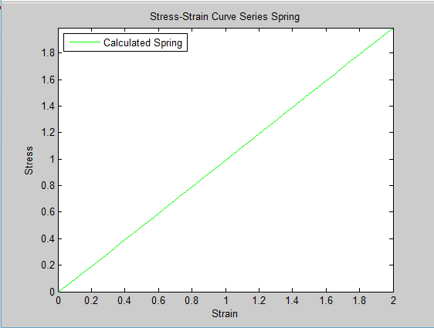

Figure 4: Stress Strain Curve for Distribution PI/8 to –PI/8

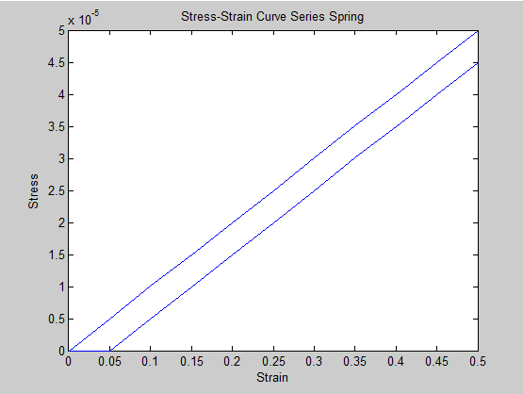

Figure 5: Individual Fibers (10) for Distribution PI/8 to -PI/8

**2)** For the previous question, a histogram against strain (*Figure 4)* was plotted. It can be seen that after a strain of .1-.15, all of the fibers are aligned and therefore contributing the stress of the system. This makes since out of the sample of individual graphed fibers, all fibers begin to contribute stress after .1. Therefore these results are expected.

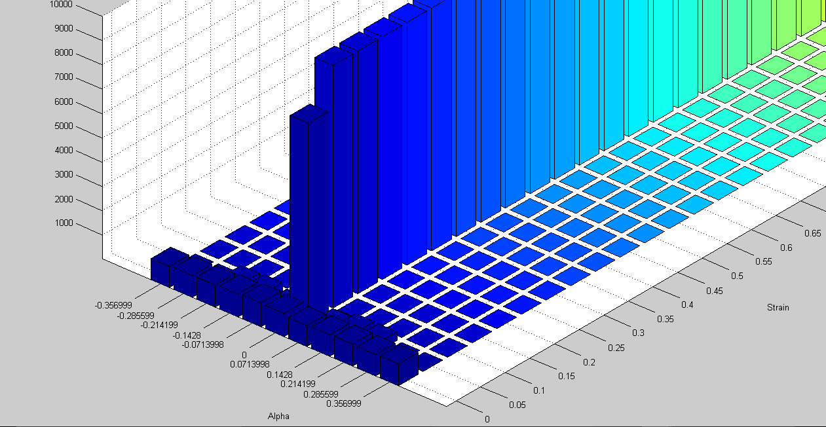

Figure 6: Angular Distribution Histogram against Strain

**3)** In this question, the range of angular distribution was broadened to PI/2 to –PI/2. The Stress-Strain curve of the system has been plotted in *Figure 8,* it can be seen that the toe of the curve has increased and the max force that the system can contribute with a given strain decreases. This can be explained that with a broader range of angular distribution a large increase of strain to line up all of the fibers. Since it takes longer for the fibers to realign, there is a decrease of total force per given strain. *Figure 7*, specifies the input parameters that were you used.



Figure 7: Input for Widely Distributed Angular Spring System

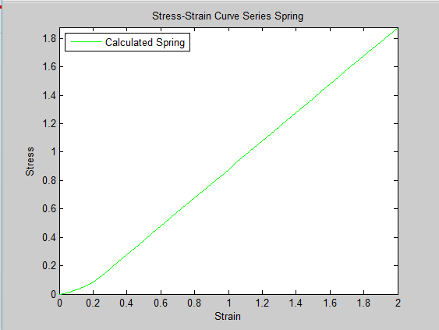

Figure 8: Stress-Strain Curve for System of PI/2 to -PI/2

**4)** For this question the linear fibers were oriented at different angular means, with different widths. *Figure 9¸*highlights the input parameters that were used, and *Figure 10* shows the stress strains curves overlapped. The strain region was lowered to .5 to get a clearer picture of what happens in the initial steps of displacement. From the stress strain curves, it is clear that the closer mean to the direction of pull (PI/4), began recoupment earlier than the PI*(3/8), since the fibers will align faster to the direction of pull. Then both curves began into a linear elastic modulus with later increments of displacement. However they do not converge, since the larger mean causes the fibers to contribute force at a later strain. In terms of distribution of fibers, for both PI/4 and PI*3/8, the larger width of distribution starting contributing force with small strain faster than the smaller width. However from *Figure 10,* it can be seen that the curves converge once all fibers are contributing force, therefore the distribution of the fibers only impact the toe of the curve.

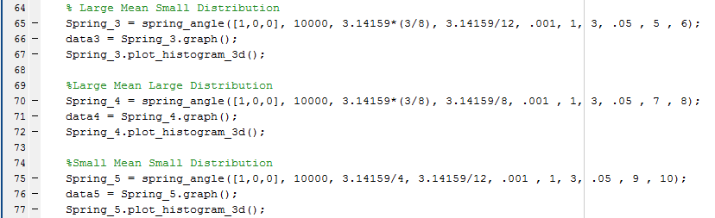



Figure 9: Changing Mean and Distribution Width for Linear Fibers

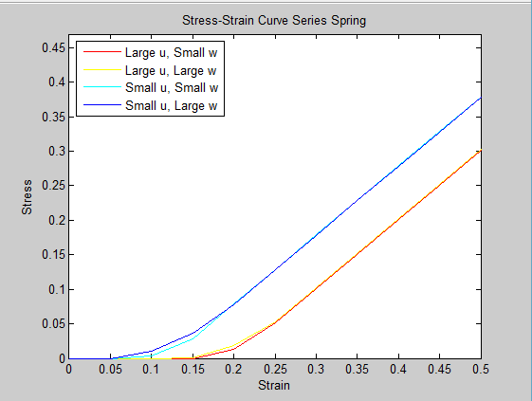

Figure 10: Changing Mean and Distribution Width Stress Strain Curve

From *Figure 11-14,* what was observed in the stress strain curve can be observed in the distribution of angles. With a larger starting angle mean, it took a large strain for all of the fibers to realign. With a large width there was a larger spread of angles, therefore with a larger spread some angles aligned more quickly than the narrowly distributed model.

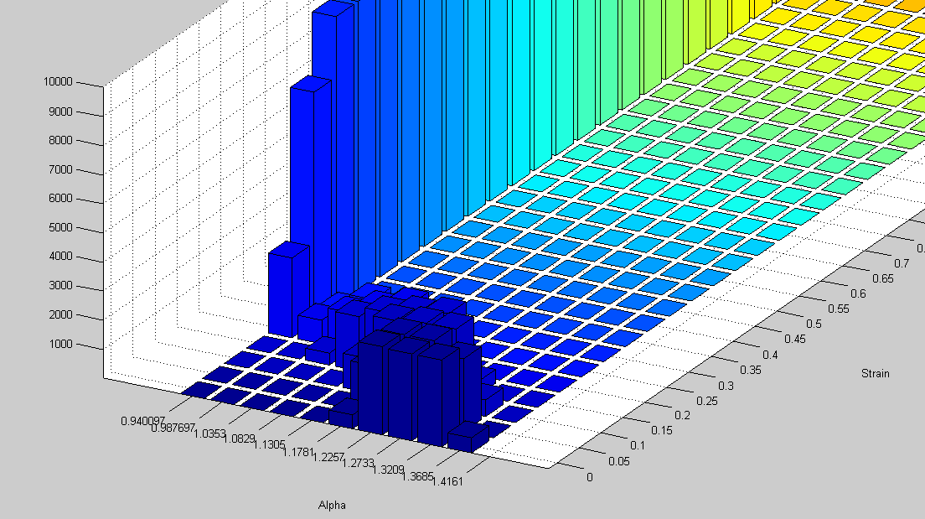

PI/2 rad

0 rad

Figure 11: Large Mean Small Distribution Alpha Distribution Histogram

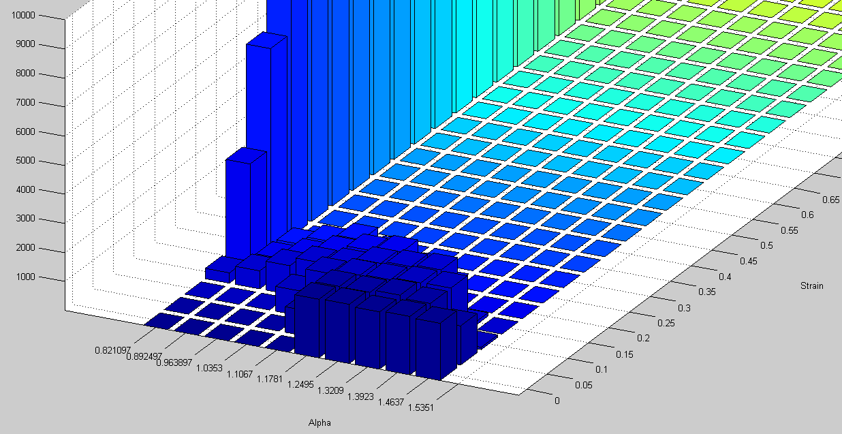

PI/2 rad

0 rad

Figure 12: Large Mean Large Distribution Alpha Distribution Histogram

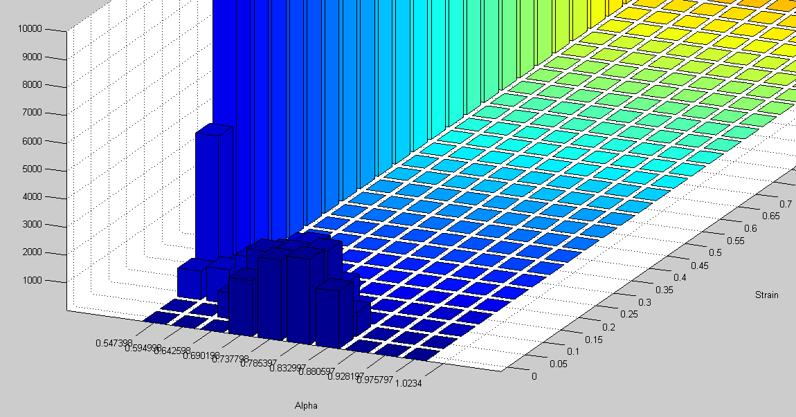

0 rad

PI/2 rad

Figure 13: Small Mean Small Distribution Alpha Distribution Histogram

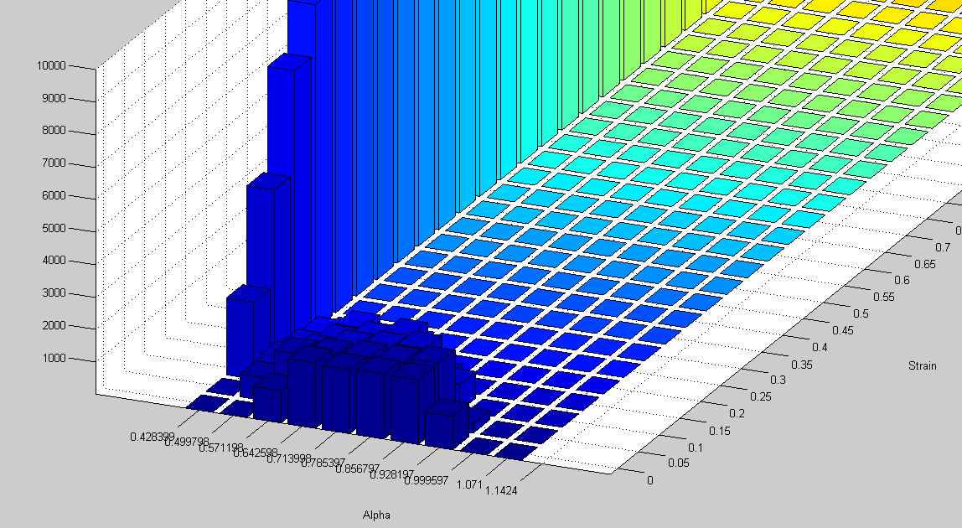

0 rad

PI/2 rad

Figure 14: Small Mean Large Distribution Alpha Distribution Histogram

**5)**

When the individual fibers are made nonlinear a change is observed with the stress strain curve. *Figure 15* is the stress strain curve and *Figure 16*, is a zoomed in stress strain curve on the knee of the curve. All alpha distribution plots should be the same since the distributions and means are the same as used in Question 4. From these two figures it can be observed that both curves don’t conform to a linear line with increased strain as in the varying length lab. Both Large mean and smaller mean, don’t converge into a single curve. Also like in question 4, as seen *Figure 16* a larger width causes the knee to start earlier.

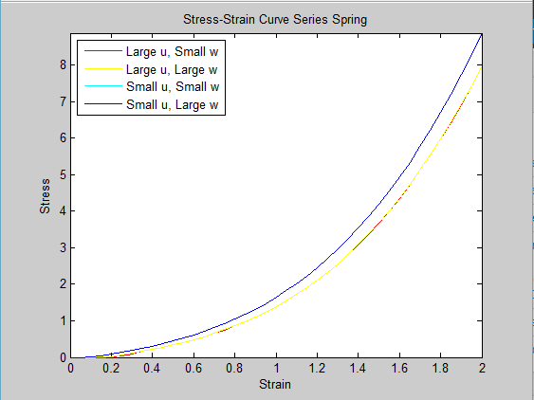

Figure 15: Stress Strain Curve for Non-Linear Case

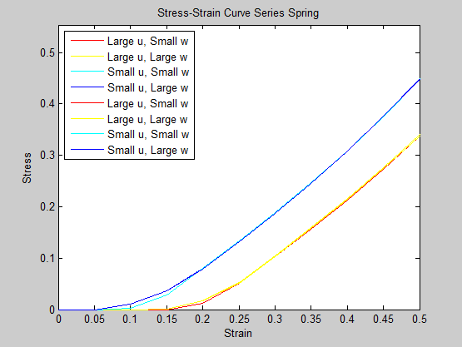

Figure 16: Stress Strain Curve for Non-Linear Case

**6)**

As seen from the results from *Figure 20-23*, the accuracy of the graph seems to be influenced by the distribution of the angles. The stress strain curves of the system of angular distrubuted fibers are not a good fit, for the single compartment model The conjecture could be made that the fit is only good when the distribution fibers have an initial distribution that includes the direction of strain/force applied. Otherwise successive steps of strain have to occur before the first group of fibers become aligned, as seen from previous questions this produces a flat stress strain curve for initial increments of curve since there is no contributing force. This makes it difficult for a fit to be sized since the force equation used in the matlab script does not accommadate for a flat region of the curve.

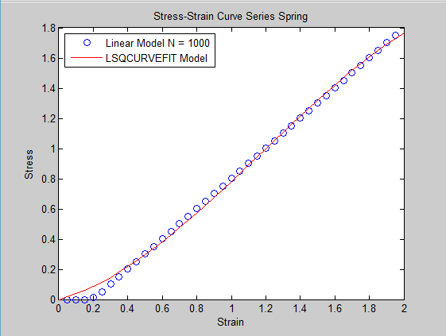

Figure 17: Large Mean Small Distribution Stress Strain Curve

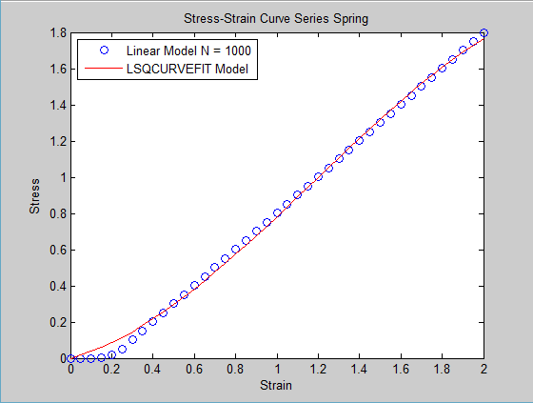

Figure 18: Large Mean Large Distribution Stress Strain Curve

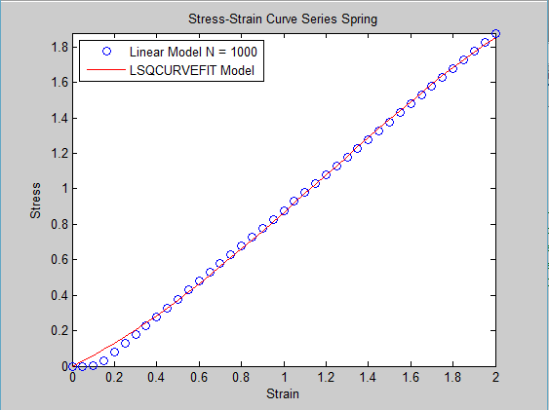

Figure 19: Small Mean Small Distribution Stress Strain Curve

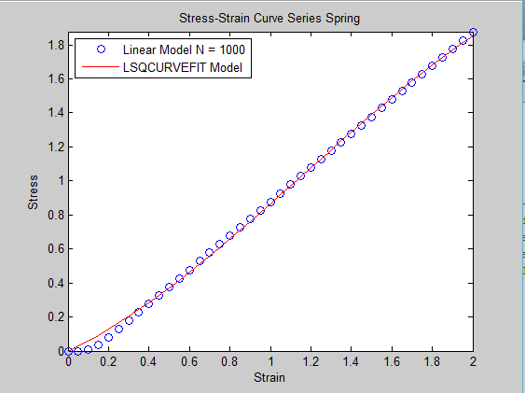

Figure 20: Small Mean Large Distribution

**7)**

Write a short discussion on what you learned about recruitment by alignment. What microscopic features of the system generate nonlinearity and an apparent “knee” in the stress-strain curve of a distributed system? Compare the parallel fibril recruitment and the fiber alignment models. Specifically, by fitting a single compartment nonlinear model to the linear but distributed models, can you speculate how the apparent macroscopic nonlinearity is related to microscopic heterogeneity in either waviness or angular distribution?

Non-linearity is generated in this case by the delay of fibers contributing force for a distributed system. If it is assumed that individual fibers are linear, then the nonlinearity /formation of the knee is caused by more and more fibers contributing stress to the overall system over a spectrum of strain. Both labs have demonstrated that it is the non-uniformity in either length or angular distribution that contributes to this. When looking at the singular compartment model, if the knee starts exactly at a displacement of 0, then by observing how large the nonlinear terms are, you can extrapolate what the microscopic heterogeneity is. A more nonlinear fit, the more the distribution of fibers there are since the knee will be larger before the stress strain curve becomes linear. This is attributed to there being a larger spread of when fibers begin contributing stress. However as observed in this lab and the previous lab on distributed lengths, if the fibers begin contributing forces after the initial displacement, the singular nonlinear compartment model would not accurately fit the curve and therefore would not be a good measure in interpreting the microscopic heterogeneity.

**Appendix:**

**Implementation of Class**

%=========Lab 3,Computational Lab 3: Effects of fiber alignment===========%

%====================on the stress-strain properties =====================%

%QUESTION 1

% Write a Matlab code that simulates the stress-strain curve of this model.

% We can directly use the derivative of Eq. 1 to compute the force on each

% spring and then we add the forces together. Assume that the system includes

% N=10000 linear identical springs each with ai=1, bi=0 and ci=0. First

% assume the distribution of angles is uniform between –PI/8 and P/8.

% Calculate the stress-strain curve of the model while stretching the system

% from length L=1 to L=3 in steps of 0.05. Also plot the force-strain curve

% on each fiber.

Spring_1 = spring_angle([1,0,0], 10000, 0, 3.14159/8, .001 , 1, 3, .05, 1, 2);

force1 = Spring_1.findForce(1.05);

data1 = Spring_1.graph();

figure(50)

for x = 1:1:10

data99 = Spring_1.graph_individual(x);

plot(data99(:,1),data99(:,2), 'b' ,'DisplayName','N/A')

hold on

end

axis([0,.5,0,max(data99(:,2))/4])

xlabel('Strain')

ylabel('Stress')

title('Stress-Strain Curve Series Spring')

%QUESTION 2

%For each strain step, save the histogram of the angles and plot the

% evolution of the distribution of fiber angles as the system is gradually

% stretched. (Hint: use the hist function with 10-12 bins).

% Does the result match you expectation?

Spring_1.plot_histogram_3d();

%QUESTION 3

%Repeat 2) with wider and wider distributions of angles reaching a uniform

% distribution between –PI/2 and PI/2. How does the shape of the stress-strain

% curve change?

Spring_2 = spring_angle([1,0,0], 10000, 0, 3.14159/2, .001 , 1, 3, .05, 3, 4);

data2 = Spring_2.graph();

% QUESTION 4

% Repeat the above with increasing the mean and the width of the distribution.

% For example, you can have a narrow distribution around ?/4, then a wider

% distribution around ?/4 and also a narrow distribution around ?/2 and a

% wider distribution around ?/2. How do the mean and width of the

% distribution affect the shape of the stress-strain curve? You should have

% realized that for a narrow distribution around say ?/2, you are simulating

% a highly anisotropic fiber system in the direction perpendicular to the

% fiber orientation, whereas a narrow distribution around 0 represents

% stretching an anisotropic fibrous tissue in the direction of fiber

% orientation. Compare the stress-strain curves of these 2 cases. To gain

% insight, plot the evolution of angle distribution on a 3D plot.

%

% Large Mean Small Distribution

Spring_3 = spring_angle([1,0,0], 10000, 3.14159*(3/8), 3.14159/12, .001, 1, 3, .05 , 5 , 6);

data3 = Spring_3.graph();

Spring_3.plot_histogram_3d();

%Large Mean Large Distribution

Spring_4 = spring_angle([1,0,0], 10000, 3.14159*(3/8), 3.14159/8, .001 , 1, 3, .05 , 7 , 8);

data4 = Spring_4.graph();

Spring_4.plot_histogram_3d();

%Small Mean Small Distribution

Spring_5 = spring_angle([1,0,0], 10000, 3.14159/4, 3.14159/12, .001 , 1, 3, .05 , 9 , 10);

data5 = Spring_5.graph();

Spring_5.plot_histogram_3d();

%Small Mean Large Distribution

Spring_6 = spring_angle([1,0,0], 10000, 3.14159/4, 3.14159/8, .001 , 1, 3, .05 , 55, 11);

data6 = Spring_6.graph();

Spring_6.plot_histogram_3d();

figure(20)

plot(data3(:,1),data3(:,2), 'r' ,'DisplayName','Large u, Small w')

hold on

plot(data4(:,1),data4(:,2), 'y' ,'DisplayName','Large u, Large w')

hold on

plot(data5(:,1),data5(:,2), 'c' ,'DisplayName','Small u, Small w')

hold on

plot(data6(:,1),data6(:,2), 'b' ,'DisplayName','Small u, Large w')

axis([0,.5,0,max(data6(:,2))/4])

xlabel('Strain')

ylabel('Stress')

title('Stress-Strain Curve Series Spring')

legend('Location','northwest')

legend('show')

%QUESTION 5

% Repeat 4) with nonlinear individual springs using bi=0.1 and ci=1.

% Large Mean Small Distribution

Spring_7 = spring_angle([1,.1,1], 10000, 3.14159*(3/8), 3.14159/12, .001 , 1, 3, .05 , 12 , 13);

data7 = Spring_7.graph();

Spring_7.plot_histogram_3d();

%Large Mean Large Distribution

Spring_8 = spring_angle([1,.1,1], 10000, 3.14159*(3/8), 3.14159/8, .001 , 1, 3, .05 , 14 , 15);

data8 = Spring_8.graph();

Spring_8.plot_histogram_3d();

%Small Mean Small Distribution

Spring_9 = spring_angle([1,.1,1], 10000, 3.14159/4, 3.14159/12, .001 , 1, 3, .05 , 16 , 17);

data9 = Spring_9.graph();

Spring_9.plot_histogram_3d();

%Small Mean Large Distribution

Spring_10 = spring_angle([1,.1,1], 10000, 3.14159/4, 3.14159/8, .001 , 1, 3, .05 , 18 , 19);

data10 = Spring_10.graph();

Spring_10.plot_histogram_3d();

figure(21)

plot(data7(:,1),data7(:,2), 'r' ,'DisplayName','Large u, Small w')

hold on

plot(data8(:,1),data8(:,2), 'y' ,'DisplayName','Large u, Large w')

hold on

plot(data9(:,1),data9(:,2), 'c' ,'DisplayName','Small u, Small w')

hold on

plot(data10(:,1),data10(:,2), 'b' ,'DisplayName','Small u, Large w')

axis([0,.5,0,max(data10(:,2))/8])

xlabel('Strain')

ylabel('Stress')

title('Stress-Strain Curve Series Spring')

legend('Location','northwest')

legend('show')

%QUESTION 6

% Fit the results from 4) with an equivalent stress-strain relation

% based on Eq. 1 as in lab 2. Use the fitting function lsqcurvefit

% from Matlab to obtain best fit of the single compartment model parameters

% to the fiber alignment model by minimizing the mean square error between

% the single compartment and distributed fiber model stresses.

z3 = curvefit(data3(:,1),data3(:,2));

z4 = curvefit(data4(:,1),data4(:,2));

z5 = curvefit(data5(:,1),data5(:,2));

z6 = curvefit(data6(:,1),data6(:,2));

**Spring Angle Class**

%Computaional Lab 3

%Matthew Mirek

classdef spring_angle

properties

SpringData

Xo = 0;

Number

Angle

Length

Threshold

Delta_X

Start_Length

Stop_Length

Step_Size

Distr_Mean

Distr_Width

f1

f2

end

methods

%Constructor class, initiliazes variables

function obj = spring_angle(A, size, mean, half_width, threshold, start, stop, step, fig1, fig2)

if nargin > 0

obj.SpringData = A;

obj.Number = size;

obj.Distr_Mean = mean;

obj.Distr_Width = half_width;

obj.Threshold = threshold;

obj.Start_Length = start;

obj.Stop_Length = stop;

obj.Step_Size = step;

obj.f1 = fig1;

obj.f2 = fig2;

obj.Angle = zeros((stop-start)/step + 1,size,'double');

obj.Length = zeros(1,size,'double');

for x = 1:1:obj.Number

obj.Angle(1,x) = obj.Distr_Mean - obj.Distr_Width + rand*obj.Distr_Width*2;

end

for Len = obj.Start_Length:obj.Step_Size:obj.Stop_Length

for x = 1:1:obj.Number

Disp = Len - obj.Start_Length;

if(Disp > 0)

index1 = uint64(Disp/obj.Step_Size + 1);

initial_angle = obj.Angle(index1 -1,x);

xlength = 1*cos(initial_angle)+ Disp;

new_angle = (abs(initial_angle)/initial_angle)*acos(xlength);

if (isreal(new_angle))

obj.Angle(index1,x) = new_angle;

else

obj.Angle(index1,x) = 0;

end

if ((abs(obj.Angle(index1,x)) < obj.Threshold)&&(obj.Length(1,x) == 0))

obj.Length(1,x) = Len - step;

end

end

end

end

end

end

function H = Create_Hist(obj, index1)

nbins = (obj.Distr_Mean - obj.Distr_Width*(10/11)):obj.Distr_Width*(10/11)/5:(obj.Distr_Mean + obj.Distr_Width*(10/11));

x = obj.Angle(index1,:);

[counts,centers] = hist(x, nbins);

%bar(centers, counts)

H = counts;

end

function plot_histogram_3d(obj)

Y = [ 0, 0 , 0 , 0 , 0 , 0 , 0 , 0 , 0 , 0, 0 ];

for Len = obj.Start_Length:obj.Step_Size:obj.Stop_Length

Disp = Len - obj.Start_Length;

index1 = uint64(Disp/obj.Step_Size + 1);

counts = Create_Hist(obj, index1);

Y = [Y; counts];

end

Y(1,:) = [];

figure(obj.f2)

bar3(transpose(Y))

title('Distribution of Alpha versus Strain')

xaxis = 0:(obj.Step_Size/obj.Start_Length):((obj.Stop_Length-obj.Start_Length)/obj.Start_Length);

ybins = (obj.Distr_Mean - obj.Distr_Width*(10/11)):obj.Distr_Width*(10/11)/5:(obj.Distr_Mean + obj.Distr_Width*(10/11));

set(gca,'XTick', 1:41)

set(gca,'YTick', 1:11)

set(gca,'XTickLabel',xaxis)

set(gca,'YTickLabel',ybins)

xlabel('Strain')

ylabel('Alpha')

end

function data = graph(obj)

results = [ 0, 0];

for x = obj.Start_Length:obj.Step_Size:obj.Stop_Length

A = [(x-obj.Start_Length)/obj.Start_Length, ...

obj.findForce(x)/obj.Number];

results = [results; A];

end

results(1,:) = [];

figure(obj.f1)

plot(results(:,1),results(:,2), 'g' ,'DisplayName','Calculated Spring')

axis([0,(obj.Stop_Length-obj.Start_Length)/obj.Start_Length,0,max(results(:,2))])

xlabel('Strain')

ylabel('Stress')

title('Stress-Strain Curve Series Spring')

legend('Location','northwest')

legend('show')

data = results;

end

function F = findForce(obj, Len)

sumf = 0;

for x = 1:1:obj.Number

Disp = Len - obj.Start_Length;

index1 = int64(Disp/obj.Step_Size + 1);

a = abs(obj.Angle(index1,x));

if (a < obj.Threshold)

Disp_off = Len - obj.Length(1,x);

indiv = obj.SpringData(1)*power(Disp_off, 1)+ obj.SpringData(2)*power(Disp_off, 2) + obj.SpringData(3)*power(Disp_off, 3);

sumf = sumf + indiv;

end

end

F = sumf;

end

function data = graph_individual(obj, fiber_index)

results = [ 0, 0];

for x = obj.Start_Length:obj.Step_Size:obj.Stop_Length

A = [(x-obj.Start_Length)/obj.Start_Length, ...

obj.find_Force_indiv(x, fiber_index)/obj.Number];

results = [results; A];

end

results(1,:) = [];

data = results;

end

function F = find_Force_indiv(obj, Len, fiber_index)

Disp = Len - obj.Start_Length;

index1 = int64(Disp/obj.Step_Size + 1);

a = abs(obj.Angle(index1,fiber_index));

indiv = 0;

if (a < obj.Threshold)

Disp_off = Len - obj.Length(1,fiber_index);

indiv = obj.SpringData(1)*power(Disp_off, 1)+ obj.SpringData(2)*power(Disp_off, 2) + obj.SpringData(3)*power(Disp_off, 3);

end

F = indiv;

end

end

end

**Curve Fit Function**

function x = curvefit(xdata,ydata)

Li = 1;

xdata = xdata + Li;

F = @(x,xdata)x(1)*power(xdata-1, 1)+ x(2)*power(xdata-1, 2) + x(3)*power(xdata-1, 3);

x0 = [1 1 1];

[x] = lsqcurvefit(F,x0,xdata,ydata);

figure(13)

plot((xdata-Li)/Li,ydata, 'bo' ,'DisplayName','Linear Model N = 1000')

hold on

plot((xdata-Li)/Li,F(x,xdata),'r' ,'DisplayName','LSQCURVEFIT Model')

hold off

axis([0,2,min(F(x,xdata)),max(ydata)])

xlabel('Strain')

ylabel('Stress')

title('Stress-Strain Curve Series Spring')

legend('Location','northwest')

legend('show')

end